This document describes the verification guide for the changes done during the **72H! JOHN HANCOCK - PROJECT COEUS USERS AND ROLES MANAGEMENT** challenge.

1. Make sure you have deployed the application correctly following the “Deployment Guide.md” at root folder
2. To verify the changes you need to have one more user to be created on AD with following detail
   1. samAccountName=” ToDeleteUser”
   2. Full Name=” ToDeleteUser”
   3. givenName=” ToDelete”
   4. sn=”User”
   5. Password =any

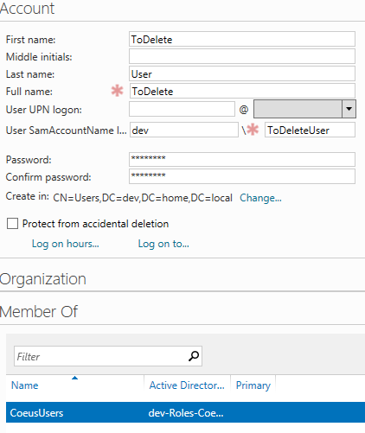

1. Make sure you have inserted test data using **\TestFiles\TestData.sql**
2. Login with admin, if you have followed user creation from deployment guide, username= CoeusAdminUser and password=password
3. Go to User Access menu, you will see all users listed which are created on AD with “CoeusUsers” group

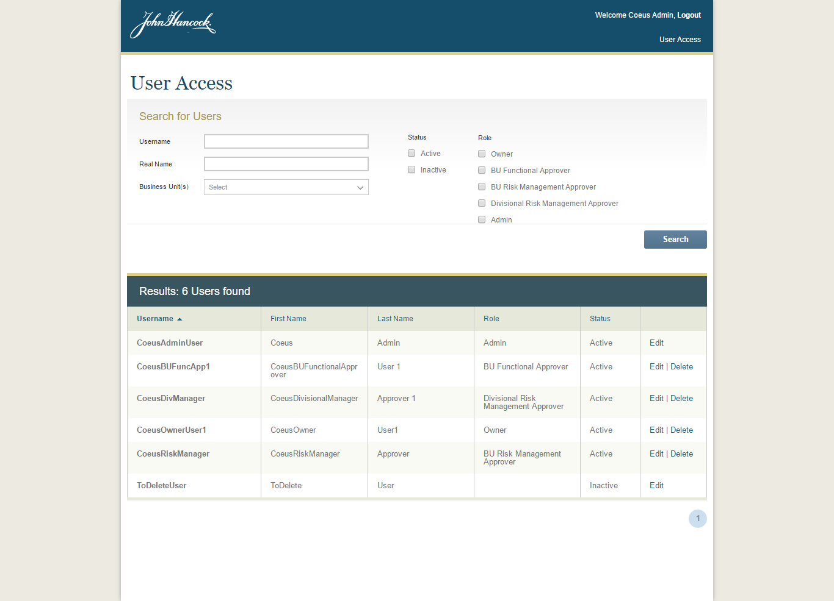

Note: Any user created on AD with configured group will be listed as Inactive. This user can’t login the app until role is configured and status set to Active. Also such user which doesn’t have user mapping info the application database won’t have delete icon.

1. Click delete icon of any user, it will delete the user mapping info. Following validations are applied:
   1. If user is ‘BUFunctionalApprover’ and he is approver i.e. selected as department head or functional area owner in any assessments with approval status other than “Approved”, “Draft” and “Rejected” then user can’t be deleted.
   2. If user is “Owner” and he has submitted any assessments which are not approved then the user cannot be deleted.

Note: only approved is not count because approved assessments cannot be edited. While rejected assessments can also be re-submitted

For other roles no need check because users are not directly referenced to assessments. Instead they are linked through the roles only.

1. Click on edit icon to update the user information, it will be saved in our database. You can verify using database as well.
   1. If user is ‘BUFunctionalApprover’ and he is approver i.e. selected as department head or functional area owner in any assessments with approval status other than “Approved”, “Draft” and “Rejected” then user’s role and status cannot be changed.

Rejected assessments is editable, so no need to check.

* 1. If user is “Owner” and he has submitted any assessments which are not approved (including rejected, as rejected can be editable) then user’s role and status cannot be changed.

For other roles no need check because users are not directly referenced to assessments. Instead they are linked through the roles only.

To verify above cases, you can update the assessment using database to appropriate status or user.

1. Delete user mapping and user’s business unit once and click to edit and try to save without selecting role and business units, it will ask for selecting role and business units

To delete user mapping including business unit

* DELETE [User_BusinessUnit] WHERE userId=<user_id>
* DELETE [UserMappingInfo] where id=<user_id>

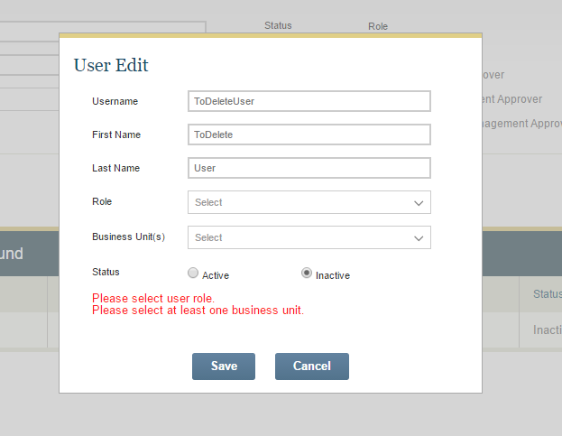

1. Verify filtering, paging, sorting

* To verify paging you can change the DEFAULT_PAGE_SIZE to smaller value in Src\App\js\config.js

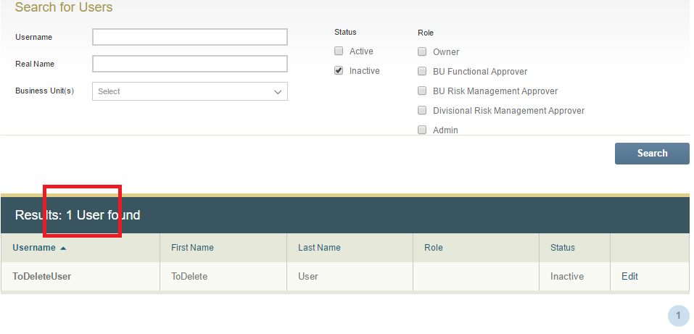

1. **Special case:**
2. Click edit icon of “ToDeleteUser”, enter the all required values and before clicking on save button, delete the user from AD. Make sure user is deleted from AD then click save button. You will see a following confirmation window.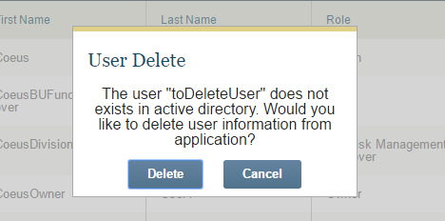

Click “Delete” button to delete the user mapping info as well. It will delete the mapping info if available.

1. Admin can’t delete himself. No delete link will be shown
2. Admin can’t change status of himself to inactive
3. If user role is changed or status is changed from Active to inactive then the tokens for the user are deleted so he would be prevented from access inappropriately
4. Bug Fixed after changes:
   1. Modified 'getCounts' in masterCtrl.js to only check awaiting & approved count if logged in user has permission for such action/menu
   2. Fixed issue of not closing popup dialog when clicking browser back button
   3. Fixed gap between the header and main content